**Data Structure LAB #1 Homework**

**[H/W 1]**

Configure your development environment and make test program.

**<Input>**

None

**<Output>**

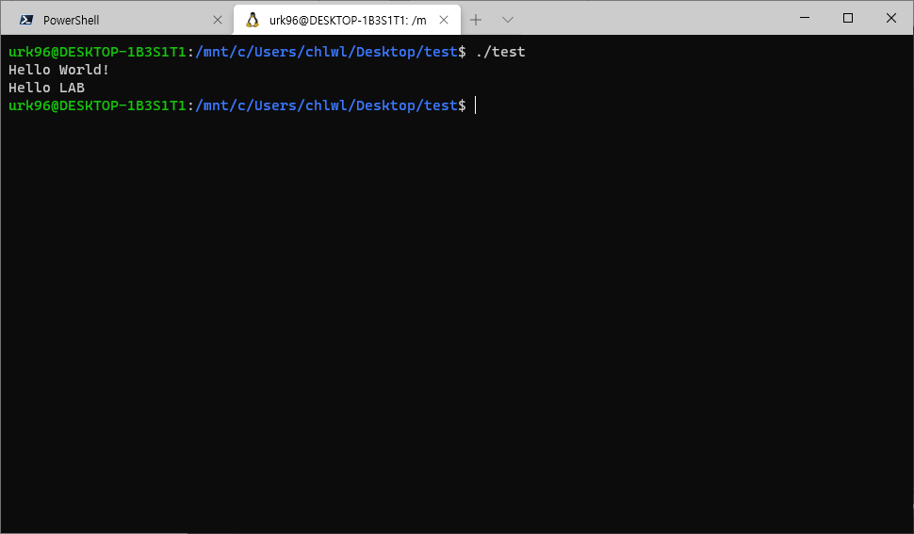

**[H/W 2] – Optional**

Test your ability to use C Pointer.

There are 3 integer pointer type variables. (A, B, C)

A has initial real value (not 0).

B and C does not have initial real value.

You perform copy action from A to B and C.

A and B has same real value and address value.

A and C has same real value, but address value is different.

After copy action, change A real value.

Finally, print A, B, C memory address value and integer value.

**<Caution & Tip>**

1. To print memory address value of pointer variable, use ‘%p’ format string.
2. You must release pointer variable at end of program. If code file does not contain release function, you may be disadvantageous.
3. Feel free to set the Initial value and changed value.
4. You must follow sample output format. If you do not follow output format, you may be disadvantageous.

**<Input>**

None

**<Output>**

